The Chinese University of Hong Kong

Department of Computer Science and Engineering

CENG2030 Fundamentals of Embedded System Design

Lab 5: Operational Amplifier

Answer Sheet

Student Name: SID:

1. **Inverting Amplifier [55%]**
   1. Create and upload your TSC circuit file. [10%]
   2. Analysis of Inverting Amplifier (Please state the **unit** clearly for each parameter)

Output Voltage VF2 (Vpp): _12V_______ [5%]

Gain in dB: $A=20log\frac{Vout}{Vin}$ = __6.0206dB___ [5%]

When Vin is positive, Vout is ___negative_______________ [5%]

V-: _0V______ [5%]

V+: __0V______ [5%]

VDIFF: __0V_______ [5%]

IR1: __3mA________ [5%]

IR2: __3mA_______ [5%]

Equation: IR1 = __ IR2____________________ [5%]

1. **Active Low Pass Filter [45%]**
   1. Create and upload your TSC circuit file. [10%]
   2. Analysis of Active LPF
      1. Collected Data [12%]

|  |  |  |  |  |  |  |  |  |  |  |  |  |
| --- | --- | --- | --- | --- | --- | --- | --- | --- | --- | --- | --- | --- |
| Frequency of VF1  (Hz) | 50 | 100 | 200 | 500 | 1k | 2k | 5k | 10k | 20k | 50k | 100k | 200k |
| Vpp of VF2  (V) | 11.98 | 11.9 | 11.64 | 10.16 | 7.48 | 4.44 | 1.8861 | 0.9519 | 0.4771 | 0.1910 | 0.0955 | 0.0477 |

* + 1. Cut-off Frequency

fc: $fc=\frac{1}{2πCR_{2}}$ = __795.77Hz____ [5%]

Vout at fc: _8.48V___ [5%]

* + 1. Graph Plotting [13%]

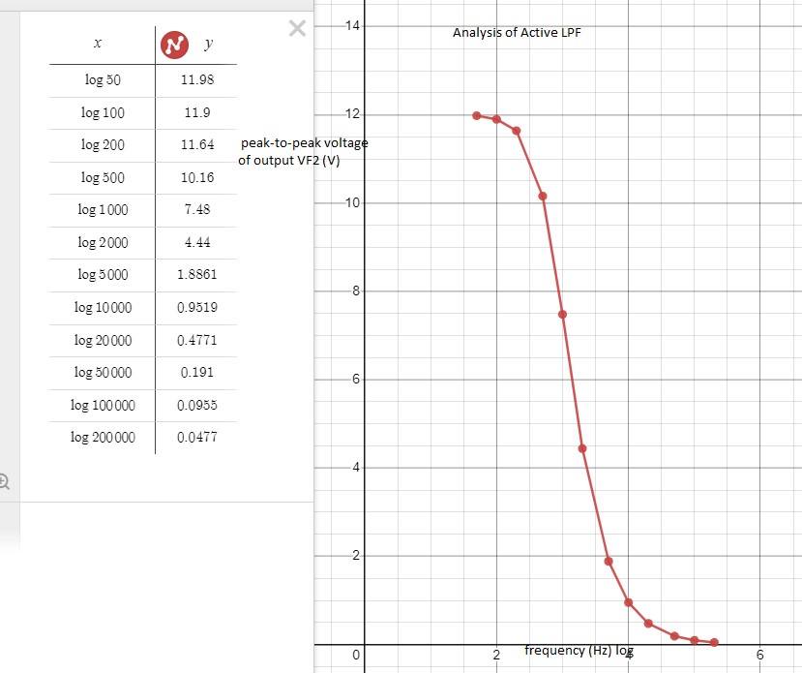

THE END